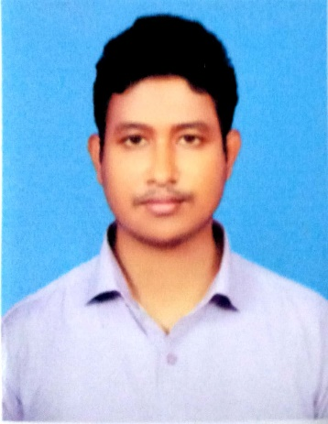

ARIFUL ALAM

Department of Physics, Mawlana Bhashani Science &Technology University, Tangail, Bangladesh.
Mobile: +8801721293009
Email: arifulalam@mbstu.ac.bd Nationality: Bangladeshi

RESEARCH INTEREST

- Material Science
- Perovskite-based SOFCs
- Electronics
- Robotics
- Astrophysics

RESEARCH SKILLS

- Have good research experience on the “Electronics & Robotics”.
- Enhancement of green energy generation through solid oxide fuel cells.
- Capable of doing work individually and in a research team, and making collaborations.
- Have good knowledge and interest on Astrophysics and Cosmology.

OTHER SKILLS

- Software skills: C, C++, Python, Mathlab, , etc.
- Proficient in English language: reading, writing, speaking, and listening.

EMPLOYMENT HISTORY & EXPERIENCE

November 2020 – continue | Assistant Professor, Dept. of Physics, MBSTU  - Teaching, full time | Tangail, Bangladesh
November 2018 – November 2020 | Lecturer, Dept. of Physics, MBSTU  - Teaching, full time | Tangail, Bangladesh

MAJOR PUBLICATIONS

- Nishat Tasnim, Md. Ridwanul Hasan*, Ariful Alam. Microcontroller based Digital System for Monitoring and Analyzing Seismic Activity. Sust J Sci Tech, ISSN-2959-3522, Vol 33(1) 2023, 22-29.
- Muktadir Md Golam, Ariful Alam, Afiya Akter Piya, and Siraj Ud Daula Shamim. "Exploring the adsorption ability with sensitivity and reactivity of C 12–B 6 N 6, C 12–Al 6 N 6, and B 6 N 6–Al 6 N 6 heteronanocages towards the cisplatin drug: a DFT, AIM, and COSMO analysis." RSC advances 12, no. 45 (2022): 29569-29584.
- Ariful Alam, Israt Khan, Sidratul Muntaha, Poonam Munshi, Ahmadullah Al Galib, and AbirMuntacir Azad. “Design and Development of Arduino Based Physical Parameter Analyzer for Unprivileged Region Agricultural System.” Jahangirnagar University Journal of Information Technology, Volume 11, June 2022.
- Piya, Afiya Akter, Siraj Ud Daula Shamim, Md Nasir Uddin, K. N. Munny, Ariful Alam, Md Kamal Hossain, and Farid Ahmed. "Adsorption behavior of cisplatin anticancer drug on the pristine, Al-and Ga-doped BN nanosheets: A comparative DFT study." Computational and Theoretical Chemistry 1200 (2021): 113241.
- Ariful Alam, Shammy Ahmed, Sharmin Rahman,Umme Habiba, Muhammad Abul Kalam Mallik, S. M. Quamrul Hasan and Md. Abdul Mannan Chowdhury “Simulation of Intensity, Track and Landfall of Tropical Cyclonic Storm Roanu over the Bay of Bengal Using WRF-ARW Model” The Dhaka University Journal of Earth and Environmental Sciences, Vol. 10(1) PP 33 – 45, 2021.
- Abir Muntacir Azad, Ariful Alam*, Umme Habiba; “Design, construct and Performance Study of Microcontroller Based Self-Powered Dual-Axis Solar Tracking System for Photovoltaic Panel” IOSR Journal of Electrical and Electronics Engineering (IOSR-JEEE), Volume 15, Issue 5 , PP 40-47, DOI: 10.9790/1676-1505014047, (Sep. – Oct. 2020)
- Mohammad Yunus, Sharmin Rahman, Ariful Alam*, KhondokarNazmusSakib. Arduino Based Smart AC-DC Voltmeter for Electronic Circuit Analysis. IOSR Journal of Electrical and Electronics Engineering (IOSR-JEEE) e-ISSN: 2278-1676,p-ISSN: 2320-3331, Volume 15, Issue 1 Ser. I (Jan–Feb 2020), PP 10-15.
- Alam, A., Abdul, M., Chowdhury, M. and Akter, F., 2019. Design and Development of Arduino Based Radiation Survey Meter with Two Scintillation Detectors. International Research Journal of Engineering and Technology.

REFERENCES

Dr. Md. Shah Alam Dr. Md. Masum Haider
Professor Professor
Dept. of Physics, Dept. of Physics,
Shahjalal University of Science and Technology, Mawlana Bhashani Science
Sylhet, Bangladesh. and Technology University.
Contact: +8801718440675 Contact: +8801812388880
shahalam032003@yahoo.com masum.phy@mbstu.ac.bd

